**WORKSHOP: VOCABULARY CLASS**

**COMPUTERS AND THE INTERNET**

# I. Listen to the audio called: I can´t imagine life without a computer and read along. Then, answer the questions below.

**Jerry and Sandra are talking about important inventions.**

**I can’t imagine life without a computer!**

**Read their conversation and answer the questions. Write complete sentences.**

**Jerry** OK, so what do you think is the most useful invention then?

**Sandra** What, in the world? Yeah, well, that’s a difficult question! Hmm, I’m pretty sure I couldn’t live without a television!

**Jerry** Really?

**Sandra** Yes, really! I mean, what would I do after school every day and at the weekends?

**Jerry** But television is just entertainment, isn’t it? Do you think it’s useful?

**Sandra** Well, yeah – it means we can learn about major news events. You know, with digital television and 24-hour channels, we can always find out what’s happening in the world. Yeah, I think it’s really useful. But anyway, what about you then? What invention do you think is the most useful?

**Jerry** Hmm … well, my computer means everything to me.

**Sandra** Do you use it a lot?

**Jerry** Yes, all the time. Yes, I’d certainly say it’s the most useful invention in our house – even more useful than my mobile phone! You know, I do my homework on it, send emails to my friends, and visit websites and chat rooms.

**Sandra** Do you have it in your bedroom?

**Jerry** Well, no, it’s in the study. You see, my mum and dad sometimes use it for work, too. And hey, if it crashes, we all get really annoyed!

**Sandra** We haven’t got a computer at home, so I don’t use one much.

**Jerry** Really, I can’t imagine life without a computer!

**Questions**:

1 What does Sandra think is the most useful invention?



2 How often does she use it?

3 In Jerry’s opinion, what is the main purpose of TV?

4 In Sandra’s opinion, which types of TV programmes are very useful?

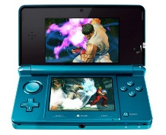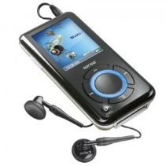

5 What is the most important thing that Jerry owns?

6 Which other useful invention does he mention?

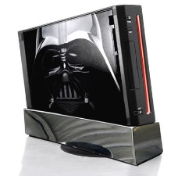7 How does his computer help him with his school work?

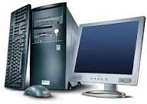8 How does he use it to communicate with his friends?

9 Who else uses Jerry’s computer?

10 Why doesn’t Sandra use a computer much?

# II. Read the sentences and complete them with the words on the left.

|  |  |  |  |
| --- | --- | --- | --- |
| **A** | attachment *n.* | **1.**  **2.**  **3.**  **4.**  **5.**  **6.**  **7.**  **8.**  **9.**  **10.**  **11.**  **12.**  **13.**  **14.**  **15.** | I can send you a message if you let me know your  .  If you click on that , it will take you to a new website.  I sent you a message this morning. Did you check your  ?  How many hours a day are you ? I bring my computer to work.  How do you upload and files?  Be careful when you decide to open a . It may have a virus!  I write about my travel experiences on my own personal ..  You can any computer document. or e-mail message that you don’t want to keep.  Oh no! I just spilled my coffee on my computer  ! My boss will be really angry..  I almost never buy books at a book store anymore. I usually read s.  You can to your e-mail account with your username and password.  Our teacher sent us an e-mail with an attachment  called homework.doc – ‘doc’ means .  My is a secret. Only I know it.  I took a photo of our school yesterday, and sent it to you as an . |
| **B** | blog *n.* |
| **D** | delete *v.* |
|  | document *n.* |
|  | download *v.* |
| **E** | e-book *n.* |
|  | e-mail address *n.* |
| **F** | file *n*. |
| **I** | in-box *n.* |
| **K** | keyboard *n.* |
| **L** | laptop *n.* |
|  | link *n.* |
| **O** | online *adj.* |
| **P** | password *n.* |
| **S** | sign in *v.* |  |